**Proceedings of the 3rd National Aerospace Propulsion Conference**

**NAPC-2020**

**Dec 17-19, 2020, B.M.S. College of Engineering, Bengaluru**

**Put paper number here (will be assigned)**

**DESIGN AND ANALYSIS OF KIIT NANOSATELLITE’S MICROPULSED PLASMA THRUSTER**

|  |  |
| --- | --- |
| **Dibyesh Satpathy**  Project Assistant, KIIT Research Wing, KIIT University,  Bhubaneswar, Odisha | **Shalika Singh**  Undergraduate Student, School of Electronics Engineering, KIIT University,  Bhubaneswar, Odisha |

|  |  |  |
| --- | --- | --- |
| **Subham Mohanty**  Undergraduate Student, School of Electronics Engineering,  KIIT University,  Bhubaneswar, Odisha | **Sidhant Patra**  Project Assistant, KIIT Research Wing,  KIIT University,  Bhubaneswar, Odisha | **Isham Panigrahi**  Associate Professor, School of Mechanical Engineering,  KIIT University,  Bhubaneswar, Odisha |

**ABSTRACT**

Mechanical and electrical designs for a Micro Pulsed Plasma Thruster have been presented here, which is to be accommodated in the KIIT University’s Nanosatellite for technological demonstration in space. Design related calculations based on dimensional limitations, power constraints and optimal thruster performance have been done and laid out. Mechanical design includes accurate Computer-Aided Design (CAD) and physical calculations of thruster casing, miniature spark plug and electrodes. The electrical design includes the Printed Circuit Board (PCB) design and circuit related calculations. The thruster being considered here uses a flared electrode and casing in order to achieve optimal thruster performance. Thrusters are well known for their issues of erosion which hamper the thruster lifetime, therefore, the correct choice of materials for electrode, casing and spark plug has been considered after a wide survey in order to limit the erosion as much as possible. Analysis of both the mechanical and electrical system has been done using SOLIDWORKS and PROTEUS software respectively, for critical validation. A space grade Micro Pulsed Plasma Thruster weighing only 130 grams capable of surviving loads of a Polar Satellite Launch Vehicle (PSLV) by Indian Space Research Organization (ISRO), and providing a specific impulse of 600 seconds has been concluded.

**NOMENCLATURE**

Nomenclature should follow customary usage. The nomenclature list should be in alphabetical order (capital letters first, followed by lowercase letters), followed by any Greek symbols, with subscripts and superscripts last, identified with headings.

**INTRODUCTION**

Pulsed Plasma Thruster (PPT) is an electric propulsion system which works based on the acceleration of plasma through Lorentz force. The attractiveness of a PPT lies on its ease of operation, effective thruster performance and efficient power usage. In addition to this, a PPT is also highly modifiable as per the requirements of a specific mission. The objective of this paper is to present a micro pulsed plasma thruster which can be accommodated in small satellites for attitude control and drag compensation. For the mission, we plan to use it for technological demonstration in Low Earth Orbit. The critical designs are based on the tight dimensional limitations of a nanosatellite and the mass budget. Application of material research has been considered for enhancing thruster performance. Similarly, for limiting the carbonization and erosion issues choosing better materials for thruster walls is the best solution. Finally, as the considered PPT is an ablative one this is a Solid Pulsed Plasma Thruster; Polyetylenetetrafluoroethylene (TEFLON) has been well researched for application in PPT as a fuel. Therefore, TEFLON has been employed as the fuel for this thruster. The KIIT Nanosatellite is an 8U satellite with the intended purpose of earth mapping and demonstrating the thruster technology. The structure has a mass of 2.2 KG and is 212x212x224 mm in dimensions. The thruster is fixed on the plate adjacent to the single solar panel and is kept at a distance from the centre of the satellite to create a moment for demonstration when the thruster is fired.

**MICRO PULSED PLASMA THRUSTER (μPPT)**

* Before calculating the dimensions of important aspects of the PPT, it is necessary to decide upon certain present conditions. An Ablative PPT has 2 kinds of configuration, Breech Fed and Side Fed. The main distinguishing factor is that in case of Breach Fed there is only a single unit of propellant supply, whereas in case of side fed there can be multiple propellant supply units. Using the side fed system, with 2 propellant supply unit is being chosen. The propellant supply unit is to be a rectangular bar, as it is relatively easy to operate upon a rectangular bar and has a simpler design than other kinds of the bar such as cylindrical bars.
* Various studies have proven that the ratio of inductance variance to initial inductance is directly linked to the acceleration of plasma 1-10. Inductance variance can be increased by increasing the aspect ratio, that is the ratio of electrode spacing to electrode width 2, 5, 6, 11, 12 and by mounting the capacitors close to the thrust chamber will ensure reduced initial inductance and therefore maximum thruster performance can be attained. To get an estimated idea of inductance variation with respect to the electrode aspect ratio, Kohlberg and Couburn approach can be considered 11.
* Electric Propulsion systems are well known for their drawbacks of contamination and erosion. The erosion can be limited through a suitable choice of wall or housing materials, however, there is always a possibility of contamination flyback, which could certainly damage the electronic components of the satellite, and could probably lead to short-circuiting. Therefore, a nozzle shaped wall has been introduced here to counter these particular drawbacks 1,13. Overall thrust also includes a gas dynamic component apart from the electromagnetic one. Therefore, the electrodes were also designed in accordance with the nozzle to maximize performance. The electrodes follow a simple design of rectangular ends 2, 8, 14, 15, 16 although other variations like semi-circular and tongue-shaped end also exist and have their pros and cons.
* Generally, spark plugs design consists of an electrode which is surrounded by a semiconducting material and is inserted through an electrode. The same concept also applies to the spark plug of PPT. Shot to shot variation in thruster performance have been reported in such spark-based systems 15. To counter this, it is recommended that the spark plug size should be much smaller than the propellant bar length 17. Coaxial spark plugs have been considered for this project, which are conventionally used in most PPTs 18, although a rectangular one is relatively easier to manufacture 17.
* Since the purpose of μPPT here is for technological demonstration via tilting the satellite, the least possible angular distance moved can prove the demonstration, which can be detected by an onboard magnetometer. Initially, however, the requirements for a 1 km Hohmann Orbit transfer from 800 Km to 801 Km were calculated, although this was never in the mission plan. On calculation, it was computed that such a transfer would require a ΔV of 0.591 m/s. By using the rocket equation19 it was computed that with 14 grams of fuel for a 13 Kg satellite with a specific impulse of the thruster being more than 548.51 seconds, the required ΔV can be obtained. The same model for calculations related to propellant size has been considered. However, realistically, the shot energy to exposed area ratio has been found to be of relevance to specific impulse 2,10,13,20. Therefore, the semi-empirical relations as given by other studies should be taken into consideration if the design and nature of the project permit it.
* AVX ceramic capacitors are being used in the electrical system because of their proven high reliability. To prove that required voltages for ablation and acceleration are acquired by the chosen electrical components, the use of 555 Timer has been mentioned here, as the nanosatellite’s onboard computer data is beyond the scope of this paper.
* A potential difference of 0.7-5 V (taken from the power subsystems of a given Nano-satellite), is fed to the 555 Timer IC. The 555 timer provides a pulsating input to a XP POWER Q-15, which helps obtain an output of 1500 V. The 1500 V voltage is then redirected to the Bank of capacitors made from AVX ceramic capacitors of 10 nF capacitance.
* Another input of 5 V is taken from the power subsystems and is fed to another 555 Timer IC to produce a pulsating voltage. The pulsating output of the 555 timer is fed to XP POWER Q-60, which helps to produce an output of 6 kV. The 6 kV output is in turn fed to a Cockcroft-Walton (CW) generator. This ladder system produces a high voltage spark of nearly equal to 12 kV which ablates the Teflon.

**DESIGN SPECIFICATIONS OF THE THRUSTER**

1. **MECHANICAL DESIGN OF THRUSTER**·
   1. **ELECTRODE DESIGN**

* An electrode length of 1.7 cm has been considered here. With a longer electrode, the wall friction could slow down the plasma and therefore reduce the Thruster Performance. If the electrodes are too short, then the Plasma would be expulsed when energy is still in the capacitor3. It is assessed that the maximum available space in axial direction would be about 2 cm; giving some free space to the back wall. For low electrical resistance, high melting point, low thermal expansion and optimal erosion resistance Tungsten-Copper alloy is being chosen as the material21. Other alternatives like thoriated tungsten, tungsten coated copper, pure tungsten or copper could also have been considered22. For perfect mechanical and electrical resistance Electrode thickness of 0.2 cm is being pitched on. Also, flared shaped electrodes at an angle of 25 degrees have been opted for maximum output.
* For optimum performance, the electrode aspect ratio can be taken to be 2. If the electrode ratio is too high many non-uniformities could arise which could reduce performance and increase Plasma Resistance. If the ratio is too small, the system could get uncontrollable1. Also, if the electrode spacing is increased, there should also be corresponding increase in voltage to keep the electric field optimized. It is critical to choose the correct value for electrode spacing. That is so because a higher value of the space will lead to inefficient discharge when the spark plug is in action. Hence, an electrode spacing of 1.1 cm and a corresponding electrode width of 0.55 cm is being settled upon.
  1. **SOLID FUEL DIMENSIONS**
* As per calculations the total mass of Teflon being carried by the nanosatellite should be 14 grams. A propellant height of 1.2 cm has been selected, which is slightly more than the electrode spacing of 1.1 cm. This has been done to avoid getting the propellant bar directly beneath the spark plug which could lead to incomplete ablation. The Teflon bar will be kept linear, and each arm length of the Teflon bar is 5.84 cm. Since the ratio of energy to the area is an important factor, the propellant width here is considered as 0.46 cm, giving a small clearance of 0.02 cm on either side of the bar; that is the width of the fuel port is 0.5 cm.
  1. **SPARK PLUG DESIGN**
* In a coaxial spark plug, there is an inner electrode which is connected to a high voltage supply and is surrounded by a semiconducting material 15, 23, 24. Tungsten has been selected as the material for the inner electrode, and it has a diameter and a length of 1.5 mm and 1 cm respectively. The surrounding semiconducting material is made of TEFLON and has an interior diameter of 1.5 mm and an exterior diameter of 2 mm. The spark plug electrode is fixated at the origin of the cathode.
  1. **𝝁PPT STRUCTURE DESIGN**
* Starting from the origin (initial position of the Teflon fuel), after 0.5 cm of the thruster chamber (out of 1.7 cm) the side walls begin. To minimize the carbonization 13 of the walls a diverging angle of 10 is introduced. About halfway later for the nozzle shape, another 25-degree divergence is introduced. Many authors consider 20 to 30-degree divergence for optimal performance25. To ensure uniform velocity profile, and the plasma sheet being expulsed with synchronization to energy stored in the capacitor, flared electrodes with 25 degrees divergence are accommodated in the nozzle. A thickness of 0.1-0.2 cm for walls is considered for proper insulation both electrically, thermally and also for surviving static loads. Instead of leaving the design with edges, proper filleting has been done beside the nozzle walls to reduce stress concentrations and to make the structure more rigid against the load brought in by a launch vehicle.
* In order to ensure a constant supply of fuel, a suitable propellant feeding system is necessary to be designed. This can be done by using springs to push the solid fuel towards the spark plug. However, compression springs and torsion springs would not be suitable as when subject to buckling they would not perform the required job properly. Therefore, a constant force spring like a negator spring has to be used 14, 26, 27. The total length of the negator spring should be more than the length of propellant, to ensure the propellant rod is consumed till the end. Commercially available negator springs of the smallest size made of stainless steel by ASRAYMOND has been opted for the thruster
* Due to the Carbonization issue, which is highly critical in Pulsed Plasma Thruster, we’re considering Torlon 4203TM for manufacturing the final model. ShapalMTM (Machine able Aluminum Nitride Ceramic) is a good alternative for Torlon 4203.

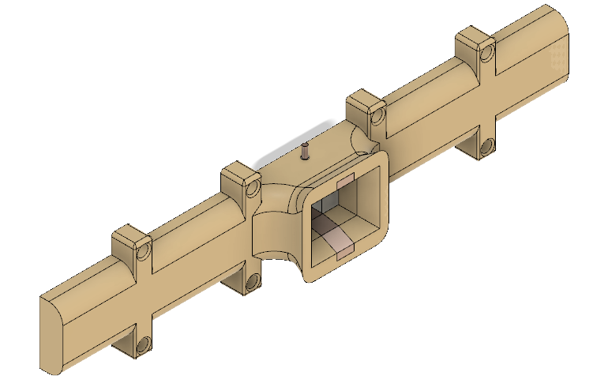**Figure 1: Isometric View of Micro Pulsed Plasma Thruster.**

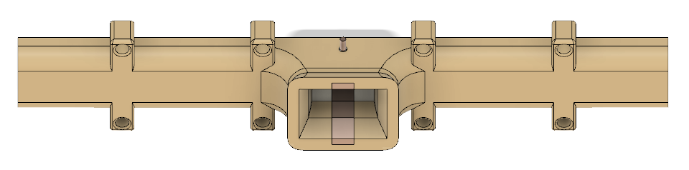

**Figure 2: View showing the use of curved surfaces beside the nozzle walls.**

1. **ELECTRICAL SYSTEM OF THE PULSED PLASMA THRUSTER**
2. **INITIATION OF SPARK PLUG**

* We will apply a pulsed input of 5 V to the 555 Timer connected to fly-back XP POWER Q-60. The pulsating input is boosted to 6000 V which in turn is fed to the CW 28. We are using the CW of 2 stages in cascade which further boosts the 6 kV to 12 kV. The high voltage of 12 kV is sufficient to produce the high voltage spark at the Teflon surface to initiate its ablation. The ladder comprises 2 stages in a cascade made of 10 nF capacitors and diodes.

|  |  |
| --- | --- |
| **Specifications** | **Value** |
| Input Voltage Range | 0.7 V - 5 V |
| Maximum Output Voltage | 6 kV |
| Maximum Output Current | 83 µA |
| Power | 0.5 W |
| Voltage Isolation |  |

**Table 1: Spark Plug specifications.**

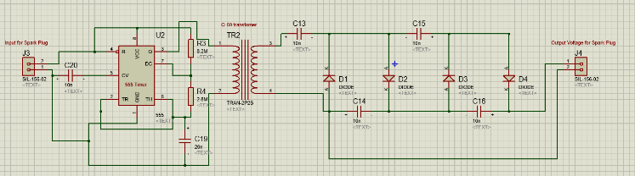

**Figure 3: Circuit Diagram for Spark Plug.**

|  |  |  |
| --- | --- | --- |
|  |  | (1) |

Voltage drop under load is calculated as:

|  |  |  |
| --- | --- | --- |
|  |  | (2) |

The ripple voltage in the case where all stage capacitance (C1 through C(2*n)) may be calculated from:

|  |  |  |
| --- | --- | --- |
|  |  | (3) |

Its observed that ripple increases rapidly with increase in the no. of stages (here n is squared).

We will be using 2 stages in cascade in order to produce a voltage nearly equal to 12 kV that would be sufficient enough to produce the high voltage spark from the output of the fly-back Q-60, at the Teflon surface and cause its ablation. So according to our calculations, we considered the capacitors of capacitance 1µF and 20 kV rated to be used in the CW. We will be using 2 high voltage diodes and 2 capacitors in a ladder and then each ladder in cascade.

|  |  |
| --- | --- |
| **Specifications** | **Values** |
| Repetitive-peak in Reversed Voltage | 20 kV |
| average Forward Current | 5 mA |
| Max surge-current | 0.51 A |
| Average Forward-Voltage Drops | 44 V |
| Reversed Recover Time | 100 ns |
| Terminal | Axial Lead |

**Table 2: Specifications of diode used in CW.**

1. **INITIATION OF ELECTRODES**

We will apply a pulsed input of amplitude 1.5 kV with Rise Time as 1µs, Fall Time as 1µs and Pulse width as 10 ms. The input is boosted to 1500 V. The boosted output is then fed to the Bank of Capacitors which in turn starts loading the capacitors. The output voltage of 1500 V from the bank is applied across the electrode plates in pulsed form to generate the pulsed plasma thrust.

|  |  |
| --- | --- |
| **Specifications** | **Values** |
| Input Voltage Range | 0.7 V - 5 V |
| Maximum Output Voltage | 1.5 kV |
| Maximum Output Current | 333 µA |
| Power | 0.5 W |
| Voltage Isolation | 500 V |

**Table 3: Electrode charging circuit data.or specification of Q-15**

For the bank of capacitors, we are using a parallel of six, series of two 1µF, 1000 V rated capacitors to form a 3.0 µF as total capacitance of the bank. The capacitor that we are using is of X7R dielectric. When the Q-15 supplies the boosted voltage, the PPT circuit will begin loading capacitors. The main capacitor is loaded to the full output voltage that needs to be applied in a pulsating manner between the electrode’s plates

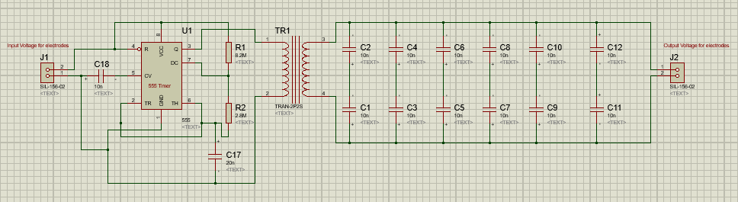

**Figure 4: Circuit Diagram for Electrode Charging.**

 If more than one Thruster is considered a switching mechanism using 4H-SiC IGBT29 across the output of the CW can be considered

1. **FINAL CIRCUIT AND PCB DESIGN**

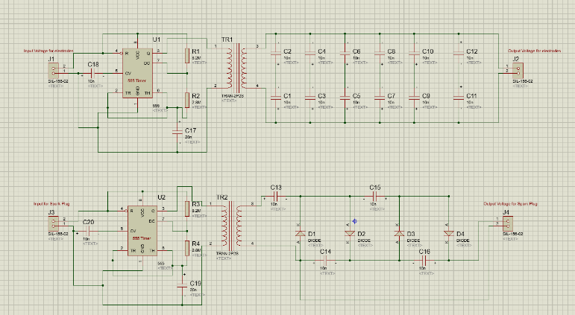

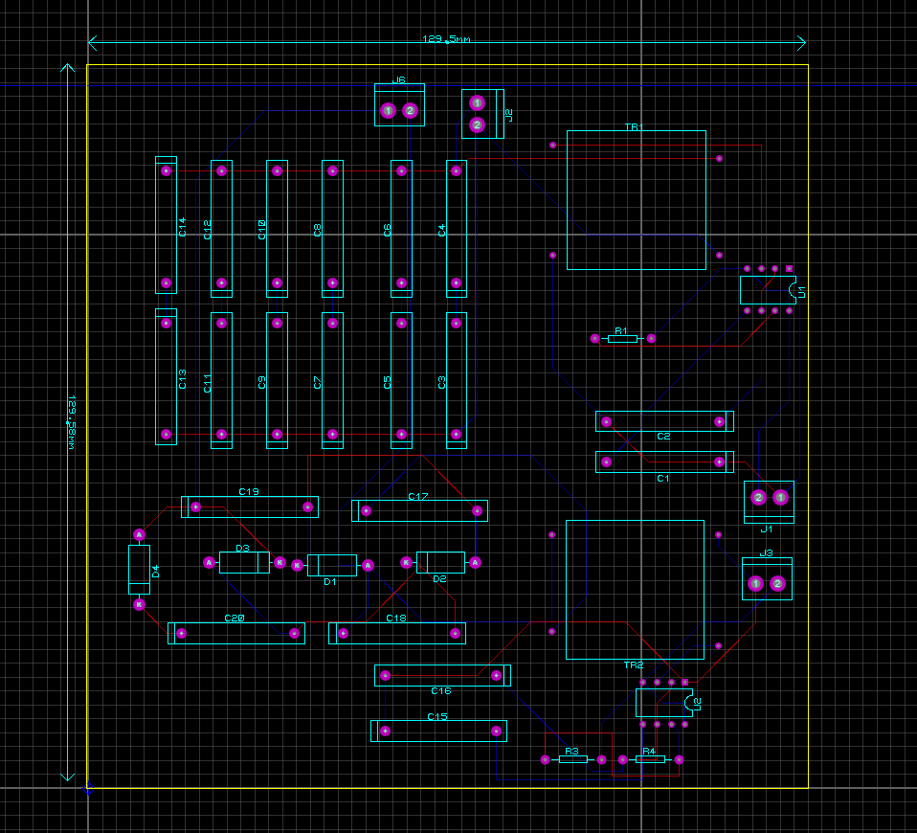

**Figure 5: Circuit Diagram and PCB Design of the μPPT electrical System**

1. **RESULT AND ANALYSIS**

The Tables below show the specifications of components, static load simulations and electrical simulations

|  |  |
| --- | --- |
| Teflon bar geometry: **Linear** | Electrode Length: **1.7 cm** |
| Teflon Mass: **14 grams** | Electrode Spacing: **1.1 cm** |
| Propellant bar Length: **5.8 cm each arm** | Electrode Width: **0.55 cm** |
| Propellant bar Height: **1.1 cm** | Electrode Thickness: **0.2 cm** |
| Propellant bar Width: **0.5** | Electrode division: **Follows Nozzle** |
| Nozzle Middle wall divergence: **10°** | Interface to satellite: **Nut and bolts** |
| Nozzle Outer Wall divergence: **25°** | Spark plug Holder: **1 mm radius** |
| Spark Plug: **0.75 mm radius, 1 cm long** | Total Mass: |

**Table 4: Specification of Mechanical Components.**

|  |  |  |  |
| --- | --- | --- | --- |
| **Components** | **Materials** | **Composition** | **Alternative** |
| Electrode | Tungsten Copper Alloy | 75%-25% W-Cu | Tungsten Coated Copper |
| Spark Plug Electrode | Pure Tungsten | 99.5% W | Pure Copper |
| Spark Plug Holder | Teflon | PTFE | ShaplMTM |
| Thruster Casing | Torlon 4203 TM | PAI | ShaplMTM |
| Negator Springs | Steel Wire | Stainless Steel | ---- |

**Table 5: Material considerations of various components.**

|  |  |  |  |  |
| --- | --- | --- | --- | --- |
| **Items** | **Manufacturer** | **Quantity** | **Mass (gm)** | **Dimensions** |
| Pulse Transformer Q-15 | XP POWER | 1 | 4.3 | 12.7mm L*12.7mm H *12.7mm W |
| Pulse Transformer Q-60 | XP POWER | 1 | 28.3 | 21.59mm L* 21.59mm H * 21.9mm W |
| Capacitor (BNC) | AVX | 15 | 1 | 19.6mm L *18.3mm H *5.08mm T |
| Diode | HVGT | 12 | 0.45 | Φ3mm * 12mm |
| Capacitor for CW | **----** | 6 | 2 | Φ18 mm |
| 8.2MΩ(for 555 Timer) | JAMECO VALUE PRO | 4 | 1 | 6.8mm L * 28mm H * Φ2.5mm |
| 2.8MΩ(for 555 Timer) | VISHAY INTER TECHNOLOFY | 4 | 1 | 6.5mm L * Φ2.5mm |
| Capacitor-10nF   (for 555 Timer) | AVX | 4 | 0.45 | 3.81 mm L* 2.54 mm W * 3.81 mm H |
| Capacitor 22nF (for 555 Timer) | AVX | 4 | 0.5 | 4.83 L * 2.29 W * 4.83 mm H |

**Table 6: Specifications of Electrical Components**

* **Static load Simulation**

To check whether the system can handle the extreme stresses of a rocket launch, a total load of 15 G is considered for the static load simulation, in addition to gravity acting against the load. Yield Stress of Torlon is 137 MPa and of Teflon is 7 MPa. As it can be seen in the simulation results below, the maximum stress formed is much less than the yield stress of the considered materials. Therefore, the design is safe for use in space.

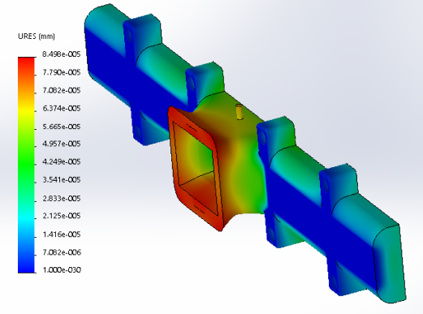

**Figure 6: Maximum deformation Plot**

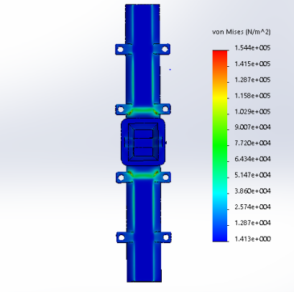

**Figure 7: Maximum Stress Plot**

* **Simulation of voltage to be applied across the electrodes**

Amplitude 1.5kV, Rise Time = 1µs

Fall Time = 1µs, Pulse width = 10ms

Frequency = 1 Hz, to the Bank of Capacitors. It produced an output voltage of 1500 V.

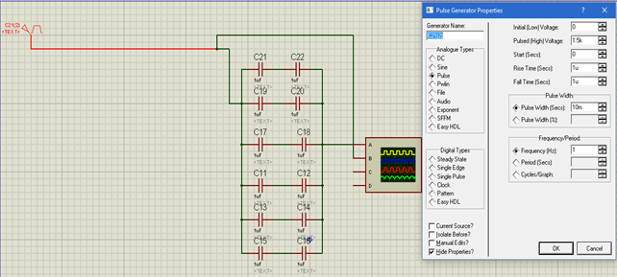

**Figure 8: Circuit Diagram and Pulse Generator Properties for Bank of Capacitors**

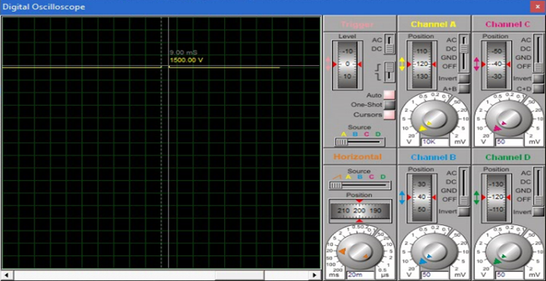

**Figure 9: Simulation result produces a voltage of 1500 V as the output of the bank**

* **Simulation of voltage to be used for the high voltage spark.**

Amplitude 6.0kV, Rise Time = 1µs

Fall Time = 1µs, Pulse width = 10ms

Frequency = 1 Hz, to the CW. It produced an output voltage of 12kV.

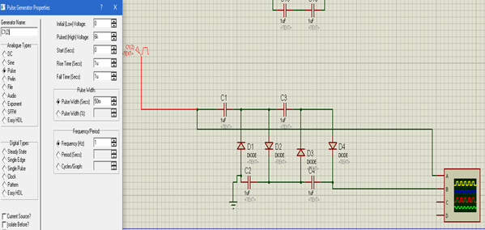

**Figure 10: Circuit Diagram and Pulse Generator Properties for CW.**

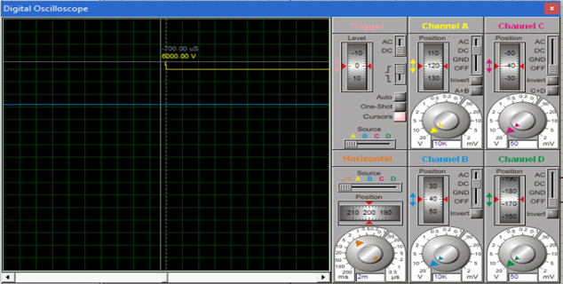

**Figure 11: Simulation of the input 6 KV given to CW**

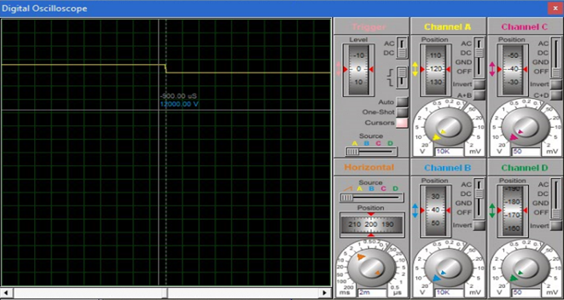

**Figure 12: Simulation of the output of High Voltage Spark (12 KV)**

* **Thruster Performance Calculation**

From the graph below 13 we find that for an E/A ratio of ~

**E = 0.5CV2 = 0.5×3×10-6×15002 = 3.375 J**

**E/A = 3.375/(2×1.2×0.46) = 3.06818 J/cm**2

By studying the graph, it can be estimated that for this thruster system the specific impulse is 600 s.

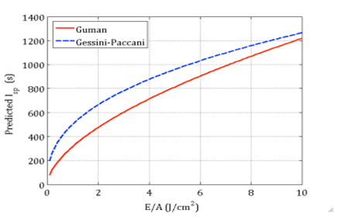

**Figure 13: Isp vs E/A graph**

# CONCLUSIONS

Put conclusions here.

**ACKNOWLEDGMENTS**

Put acknowledgments here.

**REFERENCES**

1. Jahn, R., Physics of Electric Propulsion, McGraw-­‐Hill, NewYork, 1968
2. Burton, R.L. and Turchi, P.J., "Pulsed Plasma Thruster," Journal of Propulsion and Power, vol. 14, No. 5, September-­‐October, 1998, pp. 716-­‐735.
3. Guman, W.J., "Solid Propellant Pulsed Plasma Propulsion System Design," Journal of Propulsion and Power, vol. 13, 1, January, 1976, pp. 51-­‐53.
4. Burton,R.L.,Wilson,M.J.,andBushman,S.,"Energy Balance and Efficiency of the Pulsed Plasma Thruster, "34thAIAA/ASME/SAE/ASEE Joint Propulsion Conference and Exhibit, Cleveland, OH, USA, July13-­‐15, 1998.
5. Pottinger, S.J. and Scharlemann, C.A.,"Micro Pulsed Plasma Thruster Development, "30th International Electric Propulsion Conference, Florence, Italy ,September 17-­‐20, 2007
6. Pottinger, S.J., Krejci, D., and Scharlemann, C.A., "Pulsed Plasma Thruster Performance for Miniaturised electrode Configurations and Low Energy Operation," Acta Astronautica, November 15, 2010
7. Dali, H.,Wansheng, Z.,Xiaoming, K.,and Pingyang, W.,"Effect of Ceramic Nozzle on Performance of Pulsed Plasma Thruster, "Aerospace Science and Technology, vol.12, February , 2008, pp.573-­‐578
8. Vondra, R.J., Thomassen, K., and Solbes, A., "Analysis of Solid Teflon Pulsed Plasma Thruster," Journal of Spacecraft and Rockets, vol. Vol. 7, No. 12, December, 1970, pp. 1402-­‐1406
9. Palumbo, D.J. and Guman, W.J., "Effects of Propellant and Electrode Geometry on Pulsed Ablative Plasma Thruster Performance," Journal of Spacecraft and Rockets, vol. 13, 3, March, 1976, pp. 163-­‐167
10. Gessini, P .and Paccani, G., "Ablative Pulsed Plasma Thruster System Optimization for Microsatellites, " 27th International Electric Propulsion Conference, Pasadena, CA, USA,October 15-­‐19, 2001
11. Kohlberg, I. and Coburn, W.O., "A Solution for Three Dimensional Rail Gun Current Distribution and Electromagnetic Fields of a Rail Launcher," IEEE Transactions on Magnetics, vol. 31, January, 1995, pp. 628-­‐633
12. Nawaz, A., Auweter-­‐Kurtz, M.,Herdrich, G.,and Kurtz, H.L., "Experimental Setup of a Pulsed MPD Thruster at IRS, "European Conference for Aerospace Sciences (EUCASS), Moscow, Russian Federation ,July4-­‐7th, 2005
13. Guman,W.J.,"Designing Solid Propellant Pulsed Plasma Thruster, "11th Electric Propulsion Conference, New Orleans, LA, USA, March19-­‐21, 1975
14. Guman, W.J. and Williams, T.E., "Pulsed Plasma Microthruster for Synchronous Meteorological Satellite," 10th International Electric Propulsion Conference, Lake Tahoe, NV, USA, October 31-­‐ November 2, 1973.
15. Vondra, R.J. and Thomassen, K., "Flight Qualified Pulsed Electric Thruster for Satellite Control," Journal of Spacecraft and Rockets, vol. Vol. 11, No. 9, September, 1974, pp. 613-­‐617.
16. Guman, W.J., Vondra, R.J., and Thomassen, K., "Pulsed Plasma Propulsion System Studies," AIAA Paper 70-­‐1148, 1970, pp. -­‐
17. M. Coletti a,n, F. Guarducci b, S.B. Gabriel, “A micro PPT for Cubesat application: Design and preliminary experimental results.” Acta Astronautica 69 (2011) 200–208
18. M.E. Brady, G. Aston, Pulsed plasma thruster ignitor plug ignition characteristics, Journal of Spacecraft and Rockets 20 (5) (1983)
19. Rocket Propulsion Elements, George P Sutton
20. Palumbo, D.J. and Guman, W.J., "Continuing Development of the Short Pulsed Ablative Space Propulsion System," 8th AIAA-­‐SAE Joint Propulsion Conference, New Orleans, LA, USA, November 29 -­‐ December 1, 1972.
21. Nawaz, A., Albertoni, R., and Auweter-­‐Kurtz, M., "Thrust Efficiency Optimization of the Pulsed Plasma Thruster SIMP-­‐LEX," Acta Astronautica, vol. 67, April, 2010, pp. 440-­‐448.
22. Palumbo, D., “Solid propellant pulsed plasma propulsion system development for N-S stationkeeping,” 14th International electric propulsion conference, IEPC, Princeton, New Jersey, 1979.
23. Brady, M.E. and Aston, G., "Pulsed Plasma Thruster Ignitor Plug Ignition Characteristics," Journal of Spacecraft and Rockets, vol. 20, No. 5, February 28, 1983, pp. 450-­‐451
24. G. Aston and L. C. Pless. Ignitor plug operation in a pulsed plasma thruster. Journal of Spacecraft and Rockets, 19(3):250–256, 1982.
25. Iio, J., Uezu, J., Fukushima, T., Kamishima, Y., and Takegahara, H., "Evaluation!on Impulse Bit Characteristics of Pulsed Plasma Thruster by Single Impulse Measurement," 29th International Electric Propulsion Conference, Princeton University, NJ, USA, October 31 November , 2005
26. Guman, W.J., "Development of a Short Pulsed Solid Propellant Plasma Thruster, "Fairchild Republic Company, Farmingdale, NY 10 March, 1974.
27. TY  - BOOK AU  - Cassady, R. AU  - Hoskins, William AU  - Campbell, Mark AU  - Rayburn, Christopher PY  - 2000/02/01 SP  - 7 EP  -  14 vol.4 SN  - 0-7803-5846-5 T1  - A micro pulsed plasma thruster (PPT) for the “Dawgstar” spacecraft VL  - 4 DO  - 10.1109/AERO.2000.878359 JO  - IEEE Aerospace Conference Proceedings ER  -
28. B. Kang and K. Low, "A single-switch high voltage quasi-resonant DC-DC converter for a pulsed plasma thruster," *2015 IEEE 11th International Conference on Power Electronics and Drive Systems*, Sydney, NSW, 2015, pp. 509-513.
29. Hrbud, Ivana A., Millard F. Rose and Stephen A. Meqman. “A SIMPLE MARX POWER SYSTEM FOR PULSED PLASMA THRUSTERS.” (1997).